

Trinity International College

(Under the affiliation of Tribhuvan University)

Dillibazar, Kathmandu, Nepal

Tally Lab Assignment 2

Submitted to:

Sharmila Bhattarai

Department of Computer Science and Information Technology

Trinity International College

By: Rujen Maharjan

Roll No: 15

Semester: 2nd

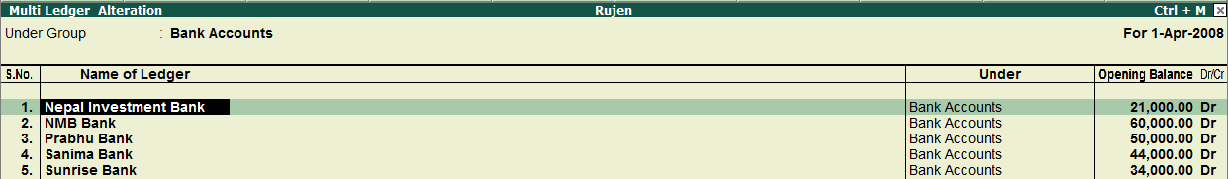

**Accounts info:**

Gateway of tally holds many features and Account Info is one of them through which we can provide Tally the details of our company’s account, which are Groups, Ledger and Voucher.

**Ledger:**

A ledger is an account or record used to store bookkeeping entries for balance sheet and income statement transactions. Ledger journal entries include accounts like cash, purchase, sales, investments, inventory and others account heads. Without a ledger, it is difficult to record transactions. All ledgers have to be classified into groups. Hence, understanding of account classification is important to work with ledgers.

**LEDGER CREATION:**

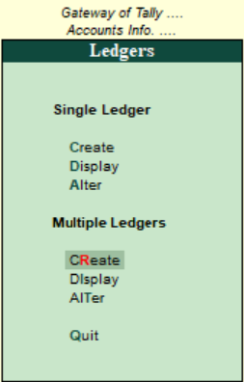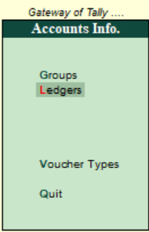As previously stated without ledger it is difficult to record business transactions so, ledger creation in tally makes it easier to create ledger as per the users’ requirement.

Steps to create new ledger:

* Go to gateway of tally.
* Click on account info.
* Click on ledger.
* Finally create multiple ledger.

We create multiple ledger since it creates individual ledger as well thus making it easier to manage.

**Create** on the multiple ledger section creates multiple new ledger head at once and enter the transactions of the company.

Single ledger creation:

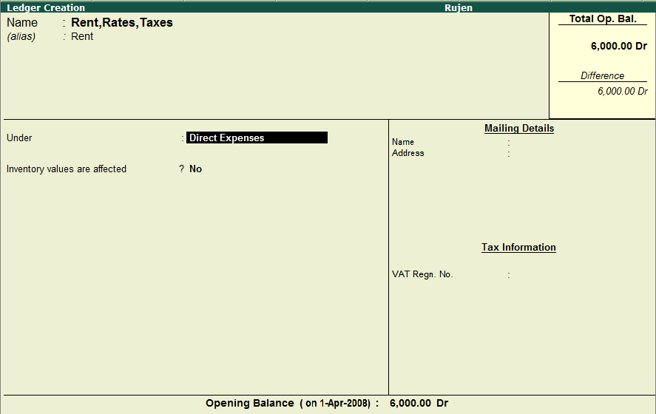

Multiple ledger creation:

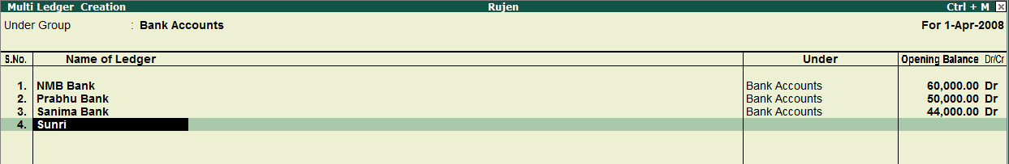

**Display** is used to show the ledger that we created since we need to check the details that we entered.

Single ledger display:

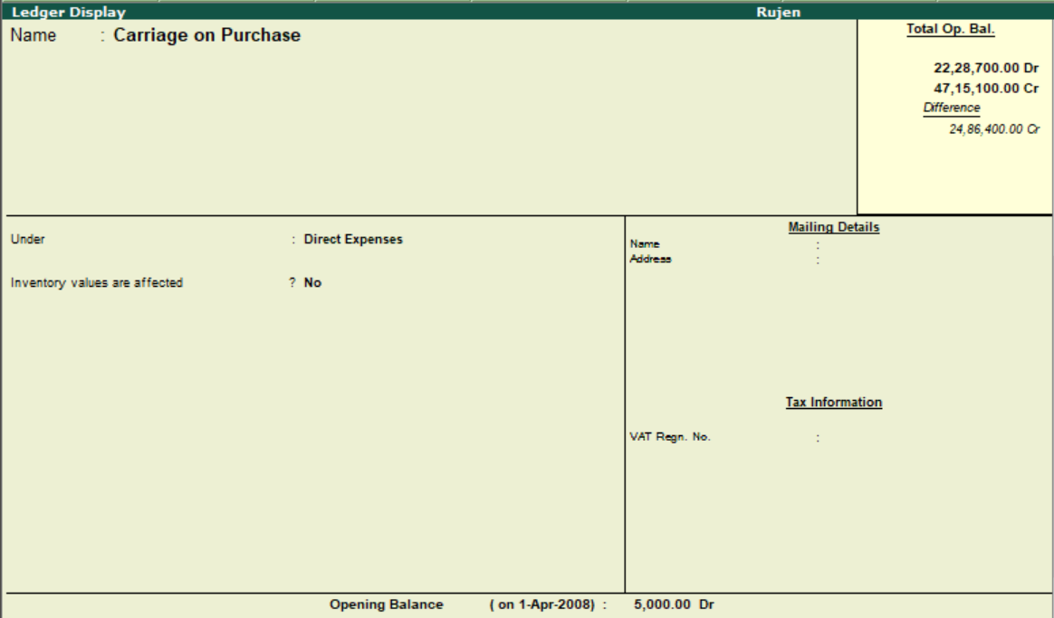

Multiple ledger display:

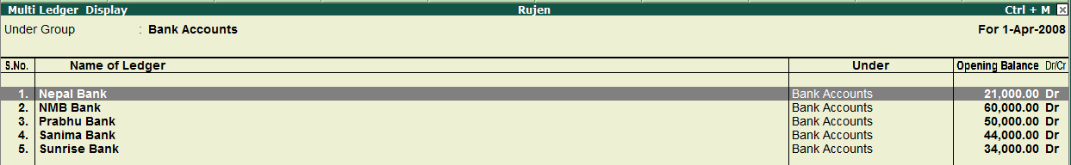

**Alter** is used to change any information that were created, i.e. editing transactions, editing ledger head, deleting ledger head, etc.

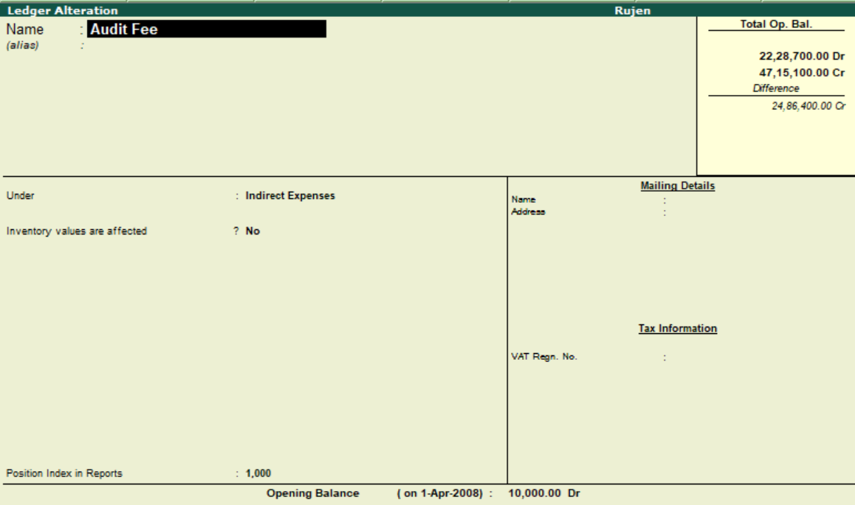Single ledger alteration

Multiple ledger alteration

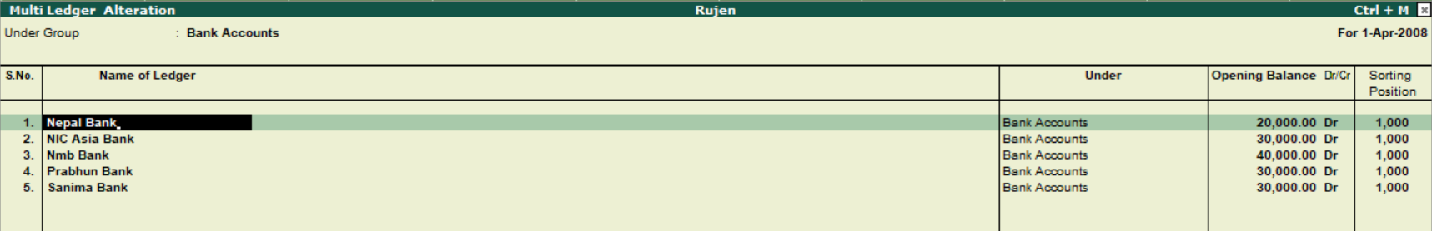

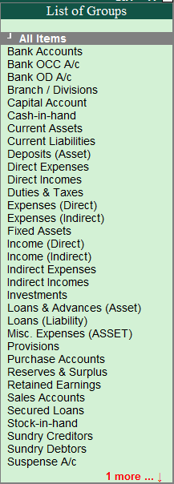The **Single Ledger** and **Multiple Ledger** have same functionboth can “**Create**”, “**Display**” and “**Alter**” the only difference is that one creates single ledger head at a time and another creates multiple ledger heads at a time.

While creating the ledgers, group selection is necessary, without selecting any group we can’t create the ledger heads.

**POSTING IN LEDGER:**

When we click on create in multiple ledger we can choose the group and start to post different accounts in respective accounts head.

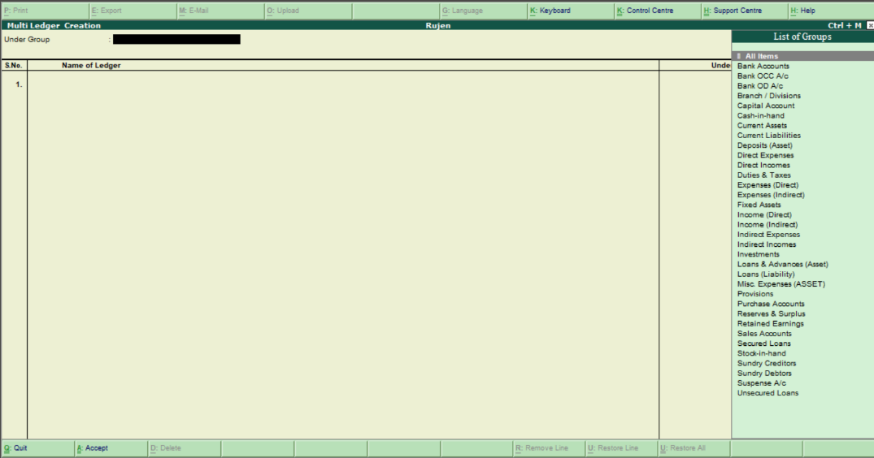

**Trial Balance:**

The trial balance is an**accounting report that lists the ending balance in each general ledger account**. This means that it states the total for each asset, liability, equity, revenue, expense, gain, and loss account. The trial balance is run as part of the month-end closing process.

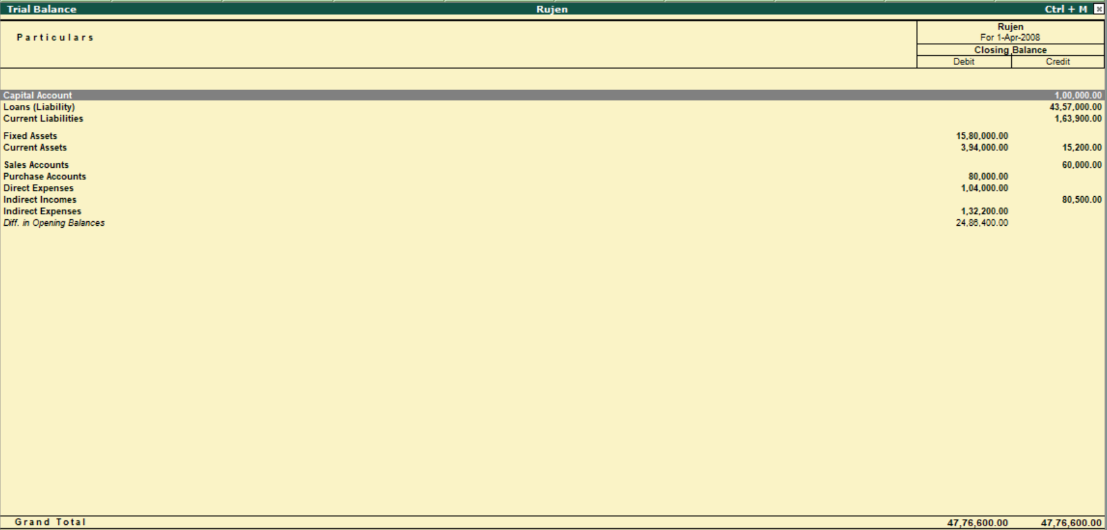

**LEDGER POSTING OF TRADING ACCOUNT IN RESPECTIVE HEAD:**

**Trading Account:** A trading account is**used to record the sale and purchase of goods/services.** This temporary account closes at the end of each accounting period. The purpose of the trading account is to show the gross profit or gross loss made in a particular time period.

* Posting in Debit side.

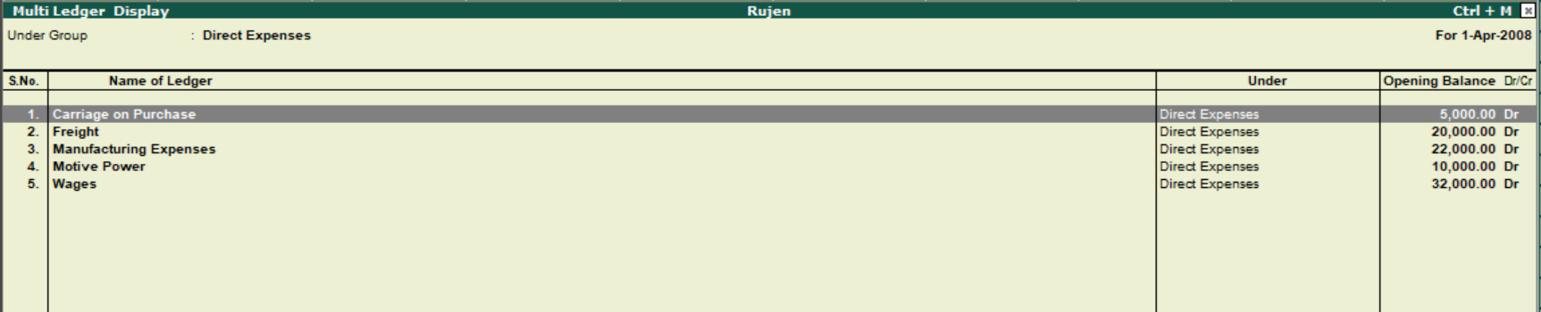

* Posting in Credit side.



**LEDGER POSTING OF PROFIT AND LOSS IN RESPECTIVE ACCOUNT HEAD:**

**Profit and Loss:** The profit and loss statement is a financial statement that summarizes the revenues, costs, and expenses incurred during a specified period.

* Posting in Debit side.

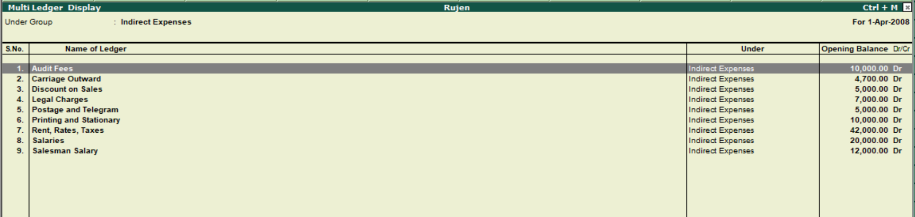

* Posting in Credit Side.

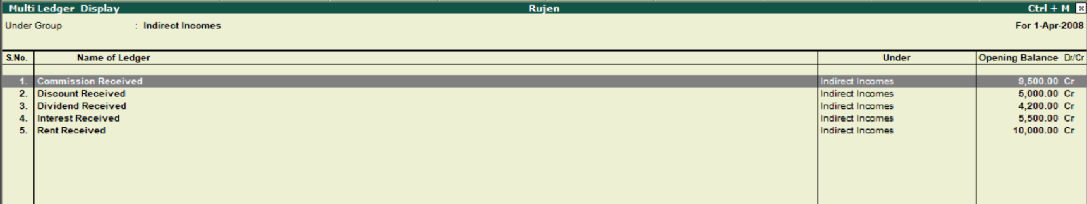

**Profit and Loss Account of Rujen PVT LTD.**

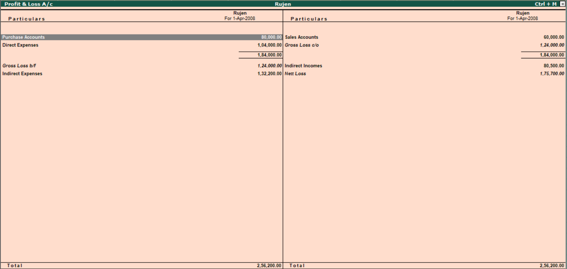

**Ledger Posting of Balance Sheet in Respective Accounts Head.**

**Balance Sheet:** Balance Sheet is the financial statement of a company which includes assets, liabilities, equity capital, total debt, etc. at a point in time. Balance sheet includes assets on one side, and liabilities on the other.

* Posting in Assets side:

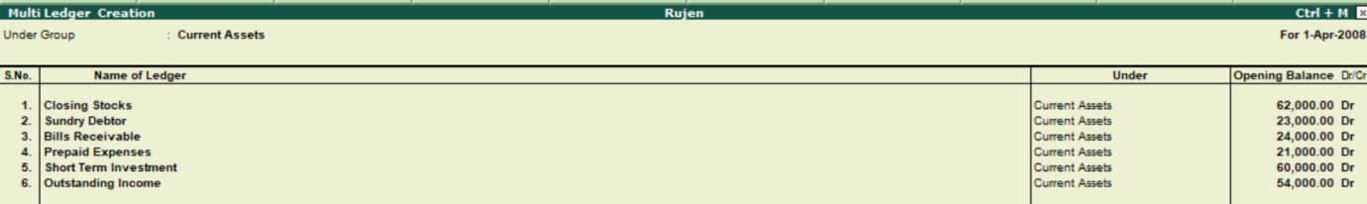

* Posting in Capital and Liabilities side:

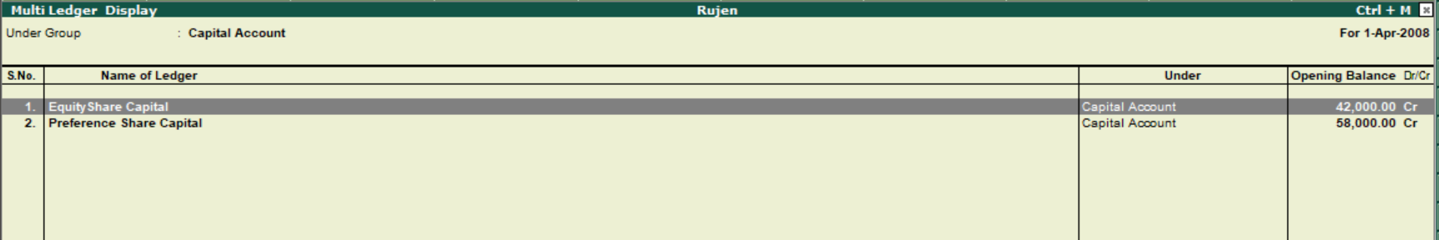

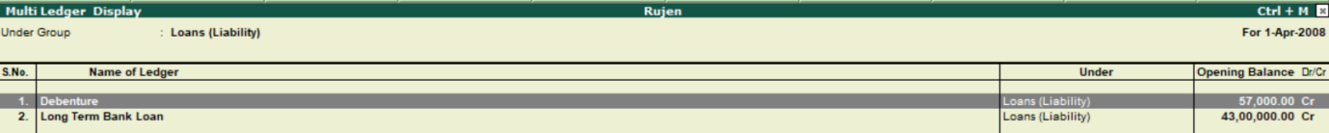

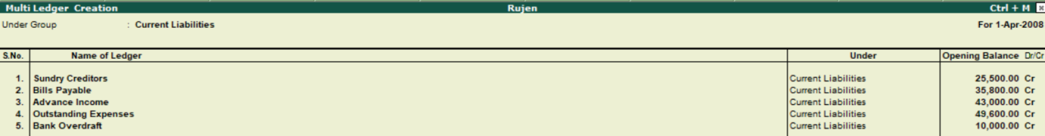

**Balance Sheet of Rujen PVT LTD**

